Dear Haiti Supporter, August, 2016
I got this picture yesterday from Haiti and it warmed my heart.
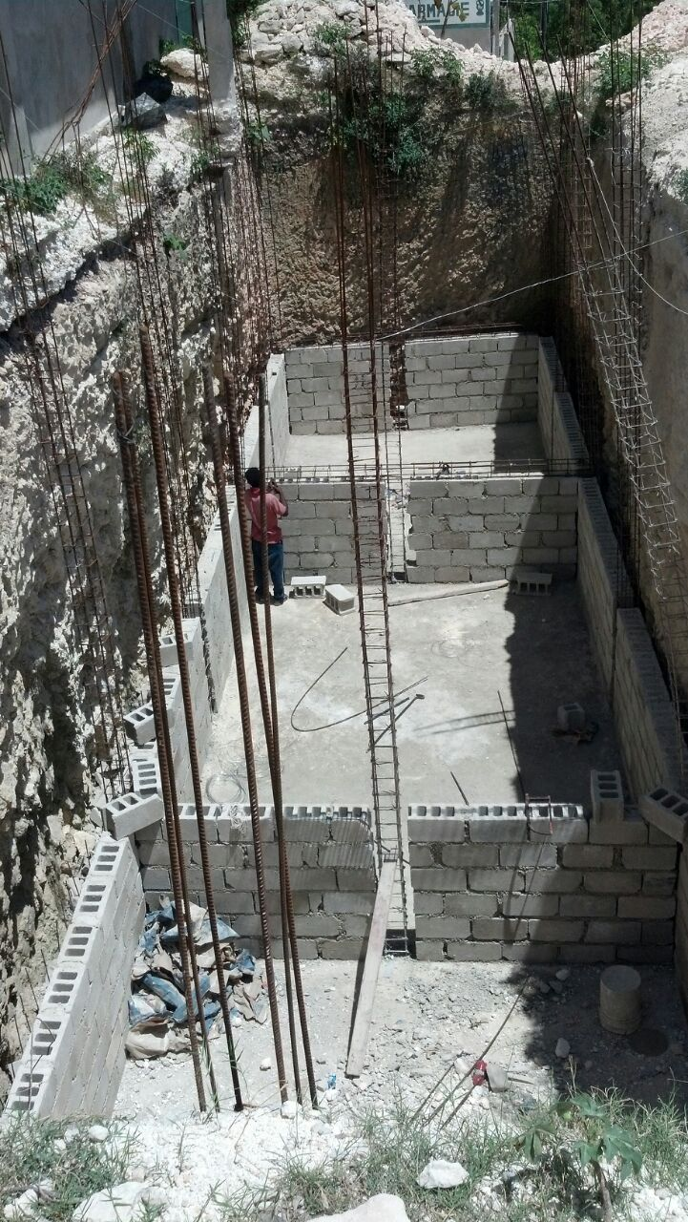
This is the very large new cistern next to the main hospital building in Merger. The additional water is crucial for the needs of the clinic, cafeteria, school, and dental clinic, especially as the clinic grows to become a hospital.
This project has been a major effort over the past two years and was helped along considerably by the Spring Break (Silver Spring UMC) and June teams (St Paul in Lusby and Glen Dale UMCs). These teams raised significant funds for completing the excavation and purchasing concrete, cinder block, rebar, and skilled labor.
We still are seeking funds to put the roof on and add the plumbing but it is exciting to see such progress.
The teams also had a big impact on the school children in Merger, and the pastors in the region. Between the two teams we had five days of pastor’s seminars and ten days of contact time with the students and the teachers.
It is impossible to quantify the encouragement the people of Merger receive as they see people return year after year. Then they know they are loved and not forgotten.
The employment and education in Merger through the work of the IOG are changing that community. About 130 children are in school and receiving a substantial lunch because of the monthly support of several donors and the significant gifts of supporting churches. St Paul UMC gave their Christmas Eve missions offering in 2015 which funded several months of teacher payroll. Glen Dale UMC continues to be a primary driving force supporting the principal, Madam Rosalyn, and the school.
One addition this year was a computer program called Haiti Internet in a Box, donated by Bethel Church in Warrenton, VA. They have a computer outreach ministry to help schools and medical facilities in Haiti with computer access for education and medical assistance. So we now have ‘internet’ access for our teachers and students where they can access Wikipedia, a book library, and Khan Academy videos on their laptops in three languages. This builds their computer skills while giving them access to a huge number of educational resources without creating the data expense of actually being on the internet. We are exploring ways to add computer training for all grade levels at the school.
Each time I return to Merger I am so impressed by the continued efforts of our Haitian partners. And I am thankful for the many who support the payroll and operating expenses in Haiti through the Institute of Grace. A trip to Haiti will open your eyes and change your life. A gift to the IOG enables Haitians to continue the work all year long of building a better future for themselves. Thanks for your support.
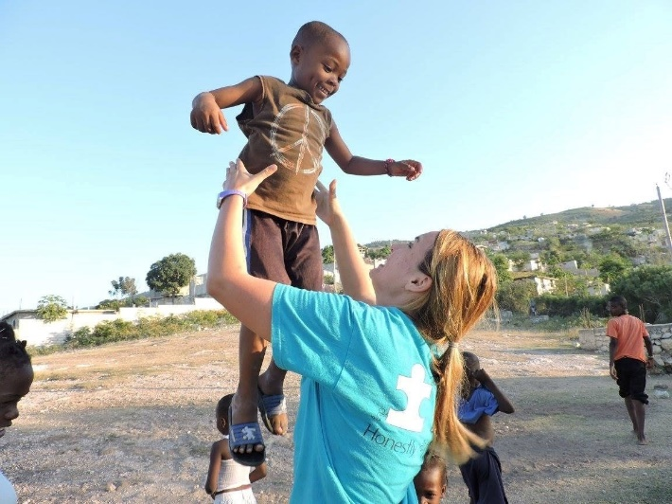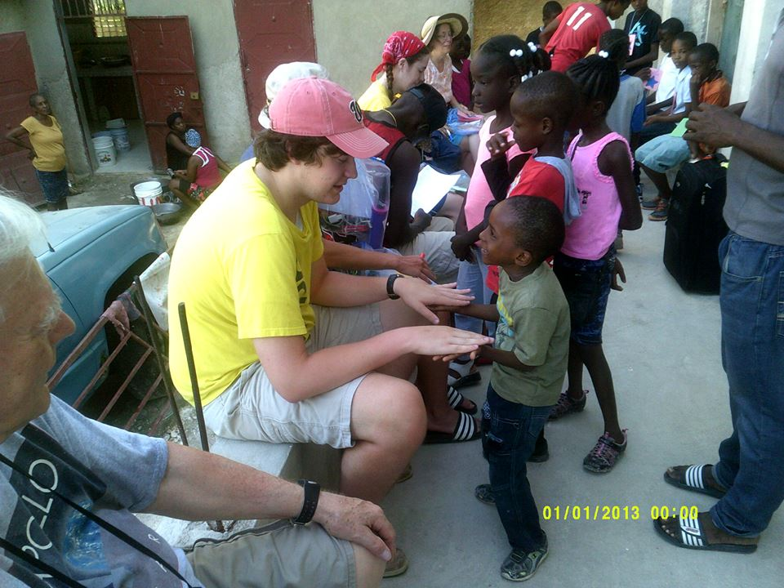
Amanda giving a lift.
Zac and friends

Planning for trips in 2017 is beginning: Give me a call or an email if you would like to lead a team next year.
David Graves, for the Institute of Grace: http://www.instituteofgrace.org/
240 601 0218
Contributions can be sent to:
IOG
PO Box 2364
Leesburg, VA 20177

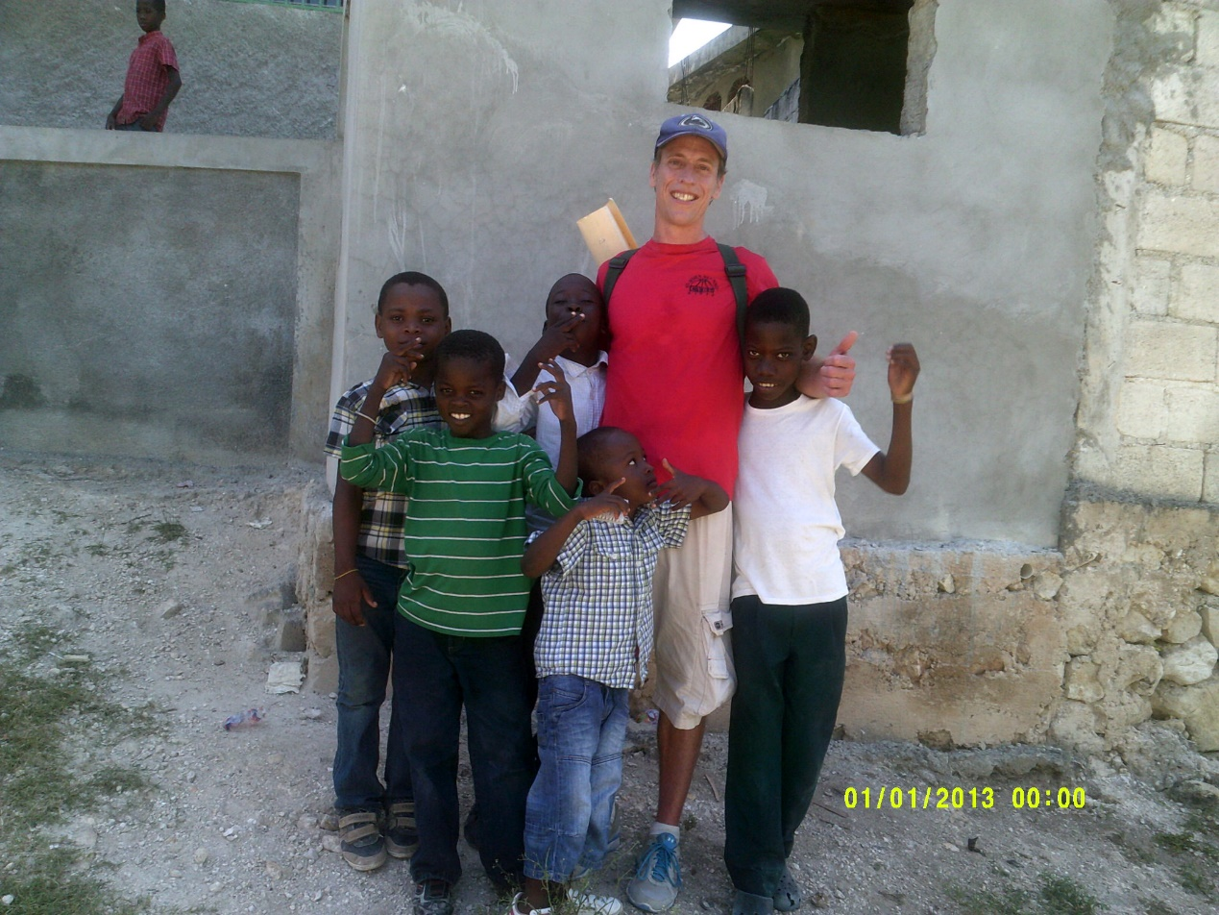
Dave T. with friends
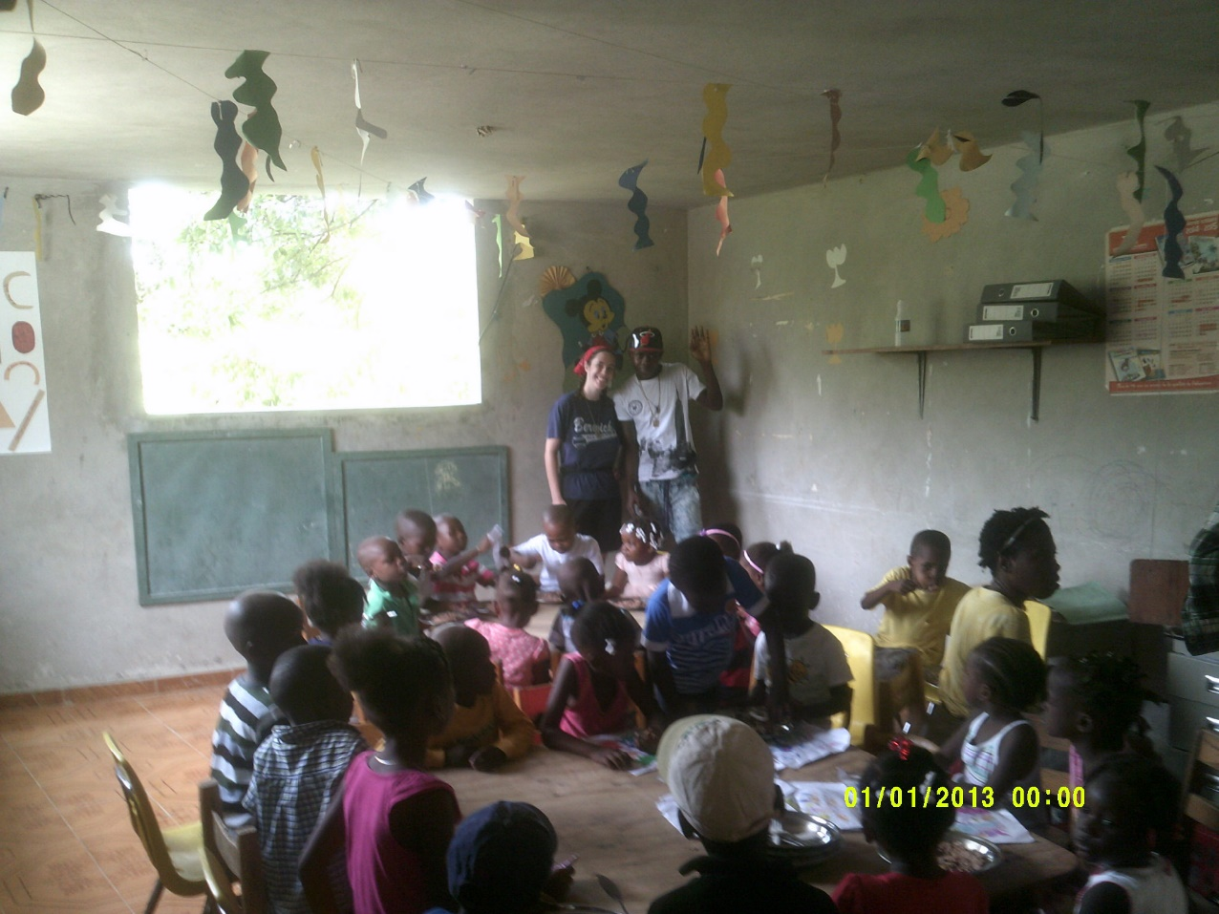
Jess T. and Yves in class

